|  |  |
| --- | --- |
| Activity | Data Type |
| Number of beatings from Wife | Discrete |
| Results of rolling a dice | Discrete |
| Weight of a person | Continuous |
| Weight of Gold | Continuous |
| Distance between two places | Continuous |
| Length of a leaf | Continuous |
| Dog's weight | Continuous |
| Blue Color | Discrete |
| Number of kids | Discrete |
| Number of tickets in Indian railways | Continuous |
| Number of times married | Discrete |
| Gender (Male or Female) | Continuous |

Q1) Identify the Data type for the Following:

Q2) Identify the Data types, which were among the following

Nominal, Ordinal, Interval, Ratio.

|  |  |
| --- | --- |
| Data | Data Type |
| Gender | Nominal |
| High School Class Ranking | Ordinal |
| Celsius Temperature | Interval |
| Weight | Ratio |
| Hair Color | Nominal |
| Socioeconomic Status | Ordinal |
| Fahrenheit Temperature | Interval |
| Height | Ratio |
| Type of living accommodation | Nominal |
| Level of Agreement | Ordinal |
| IQ(Intelligence Scale) | Interval |
| Sales Figures | Ratio |
| Blood Group | Nominal |
| Time Of Day | Ordinal |
| Time on a Clock with Hands | Interval |
| Number of Children | Ratio |
| Religious Preference | Nominal |
| Barometer Pressure | Ordinal |
| SAT Scores | Interval |
| Years of Education | Ratio |

Q3) Three Coins are tossed, find the probability that two heads and one tail are obtained?

ANSWER : 3times

Q4) Two Dice are rolled, find the probability that sum is

1. Equal to 1 ANSWER : Zero
2. Less than or equal to 4 ANSWER : 6/36 = 0.16
3. Sum is divisible by 2 and 3 ANSWER : 6/36 = 1/6 =0.16

Q5) A bag contains 2 red, 3 green and 2 blue balls. Two balls are drawn at random. What is the probability that none of the balls drawn is blue?

ANSWER : 10/21

Q6) Calculate the Expected number of candies for a randomly selected child

Below are the probabilities of count of candies for children (ignoring the nature of the child-Generalized view)

|  |  |  |
| --- | --- | --- |
| CHILD | Candies count | Probability |
| A | 1 | 0.015 |
| B | 4 | 0.20 |
| C | 3 | 0.65 |
| D | 5 | 0.005 |
| E | 6 | 0.01 |
| F | 2 | 0.120 |

Child A – probability of having 1 candy = 0.015.

Child B – probability of having 4 candies = 0.20

ANSWER : = 1*0.015 + 4*0.20 + 3*0.65 + 5*0.005 + 6*0.01 + 2*0.120

= 0.015 + 0.80 + 1.95 + 0.025 + 0.06 + 0.24

= 3.09

Q7) Calculate Mean, Median, Mode, Variance, Standard Deviation, Range & comment about the values / draw inferences, for the given dataset

* For Points, Score, Weight

Find Mean, Median, Mode, Variance, Standard Deviation, and Range and also Comment about the values/ Draw some inferences.

**Use Q7.csv file**

ANSWER :

Mean Median Mode Variance Std Deviation Range

**POINTS: 3.59 3.70 3.92 11.08 3.32 2.17**

**SCORE: 3.21 3.33 3.44 9.90 3.14 3.91**

**WEIGHT: 17.85 17.71 17.02 264.78 16.27 8.40**

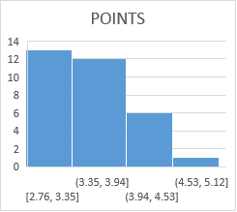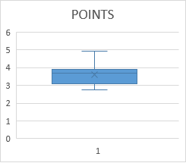

**Positive Skewness**

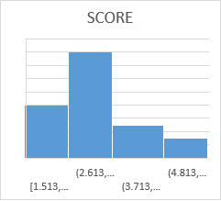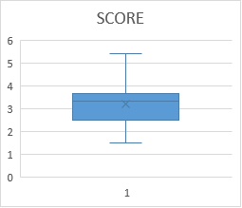

**Positive Skewness**

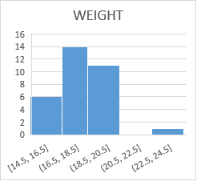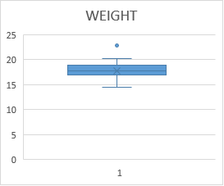

Q8) Calculate Expected Value for the problem below

1. The weights (X) of patients at a clinic (in pounds), are

108, 110, 123, 134, 135, 145, 167, 187, 199

Assume one of the patients is chosen at random. What is the Expected Value of the Weight of that patient?

ANSWER : Expected Value =145.33

**Q9) Calculate Skewness, Kurtosis & draw inferences on the following data**

**Cars speed and distance**

**Use Q9_a.csv**

ANSWER : Skewness = -0.11751 Kurtosis = -0.5089

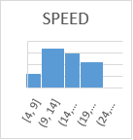

Skewness = 0.8068 Kurtosis = 0.4050

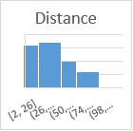

**SP and Weight(WT)**

**Use Q9_b.csv**

ANSWER : Skewness = 1.6114 Kurtosis = 2.997

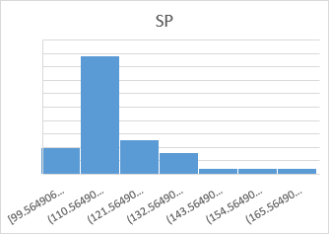

Skewness = -0.6147 Kurtosis = 0.9502

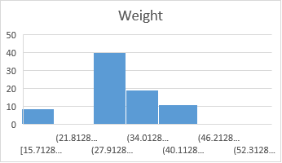

**Q10) Draw inferences about the following boxplot & histogram**



ANSWER : +Ve Skewness



ANSWER : +Ve Skewness

**Q11)** Suppose we want to estimate the average weight of an adult male in Mexico. We draw a random sample of 2,000 men from a population of 3,000,000 men and weigh them. We find that the average person in our sample weighs 200 pounds, and the standard deviation of the sample is 30 pounds. Calculate 94%,98%,96% confidence interval?

ANSWER : X-bar = 200, sd = 30, n = 2000 formula = X+Z*Sd/sqrt(n)

Z score = 94% = 1.89 = 201.26, 98% = 0.99 = 200.66, 96% = 0.98 = 200.65.

**Q12)** Below are the scores obtained by a student in tests

**34,36,36,38,38,39,39,40,40,41,41,41,41,42,42,45,49,56**

1. Find mean, median, variance, standard deviation.

ANSWER : Mean = 41.0

Median = 40.5

Variance = 24.11

Standard Dev = 4.91

1. What can we say about the student marks?

ANSWER : Mean = Median

Q13) What is the nature of skewness when mean, median of data are equal?

ANSWER : Zero Skewness

Q14) What is the nature of skewness when mean > median ?

ANSWER : Positively Skewness

Q15) What is the nature of skewness when median > mean?

ANSWER : Negatively Skewness

Q16) What does positive kurtosis value indicates for a data ?

ANSWER : Positive values of kurtosis indicate that a distribution is peaked and possess thick tails.

Q17) What does negative kurtosis value indicates for a data?

ANSWER : Negative kurtosis value indicates that a distribution has lighter tails

Q18) Answer the below questions using the below boxplot visualization.



What can we say about the distribution of the data?

ANSWER : Interquartile Range

What is nature of skewness of the data?

ANSWER : Negatively Skewness

What will be the IQR of the data (approximately)?

ANSWER : 10

Q19) Comment on the below Boxplot visualizations?



Draw an Inference from the distribution of data for Boxplot 1 with respect Boxplot 2.

Q 20) Calculate probability from the given dataset for the below cases

Data _set: Cars.csv

Calculate the probability of MPG of Cars for the below cases.

MPG <- Cars$MPG

1. P(MPG>38) ANSWER : 33/81

b. P(MPG<40) ANSWER : 67/81

c. P (20<MPG<50) ANSWER : 69/81

Q 21) Check whether the data follows normal distribution

1. Check whether the MPG of Cars follows Normal Distribution

Dataset: Cars.csv

ANSWER : The MPG of cars follows Normal Distribution we observe the below graph.

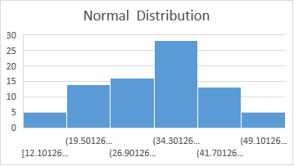

1. Check Whether the Adipose Tissue (AT) and Waist Circumference(Waist) from wc-at data set follows Normal Distribution

Dataset: wc-at.csv

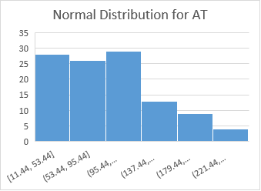

ANSWER : The Adipose Tissue (AT) is not follows Normal Distribution we clearly observe that from above graph.

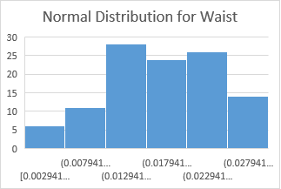

ANSWER : The Waist is not follows Normal Distribution we clearly observe that from above graph.

Q 22) Calculate the Z scores of 90% confidence interval,94% confidence interval, 60% confidence interval

ANSWER : Z score of 90% = 1+0.90/2 = 0.95 = 1.66

Z score of 94% = 1+0.94/2 = 0.97 = 1.89

Z score of 60% = 1+0.60/2 = 0.80 = 0.85

Q 23) Calculate the t scores of 95% confidence interval, 96% confidence interval, 99% confidence interval for sample size of 25

ANSWER : df = 25

n-1= 25-1 =24

t score of 95% = 2.064

t score of 96% = 2.172

t score of 99% = 2.797

Q 24**)** A Government company claims that an average light bulb lasts 270 days. A researcher randomly selects 18 bulbs for testing. The sampled bulbs last an average of 260 days, with a standard deviation of 90 days. If the CEO's claim were true, what is the probability that 18 randomly selected bulbs would have an average life of no more than 260 days

Hint:

rcode 🡪 pt(tscore,df)

df 🡪 degrees of freedom

ANSWER : X sample mean = 260

µ population mean = 270

Standard Dev S = 90

Sample n = 18

t = X - µ/s/sqrt(n) = -0.4714

degrees of freedom df = 18-1= 17.